Donor Privacy Policy
We are absolutely committed to maintaining confidentiality and protecting the privacy of our employees, donors, volunteers, community partners and others who have placed faith in Heart of the Ozarks United Way.
We therefore:
- Ensure that all information, which is confidential, privileged or nonpublic, is not disclosed.
- Respect the privacy rights of all individuals in the performance of their Heart of the Ozarks United Way duties.
- Prohibit all employees and volunteers from engaging in any financial transaction using non-public or confidential information to further their own private interest.
- Justify the reliance that donors, corporations, and others have in our ability to utilize and manage information with the highest degree of confidentiality by ensuring that our computer and management information systems are protected from unauthorized use.
- Respect the wishes of donors who may prefer to remain anonymous.

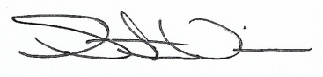 6/28/2021
_________________________________ ______________________
Heart of the Ozarks United Way Date
Board President

